Sulz am Neckar, April 2022

Wired indexing plungers with status sensor: low maintenance and reliable

HEINRICH KIPP WERK has now added a wired indexing plunger with status sensor to its range as an alternative to the wireless Bluetooth version. This product makes users of e.g. machine tools, assembly and testing fixtures or packaging machines independent of battery runtimes. Furthermore, interference-free signal transmission is guaranteed at all times even over longer ranges with obstructions in between. These new indexing plungers are part of the FEATUREgrip product series that enables intelligent process monitoring.

The integrated inductive sensor of the indexing plunger detects the actuated status. The signal is processed in the mushroom grip and sent to the machine control; a two-metre, three-core cable is provided for this as standard. The sensor reacts as soon as the pin
is retracted 1 mm. This enables the machine control to determine e.g. that the machining cycle will not start until all pins are in the correct position.

The wired construction components are rated IP67 and are therefore resistant to water spray, contact safe and sealed against dust. In addition, users can also choose between hardened or non-hardened stainless steel versions. Models with pin diameters of 5-12 mm and thread sizes M10 to M20 are available.

Indexing plungers with status sensor from KIPP are highly suitable for e.g. fixating and locking in guide systems, monitored assembly equipment, the classical swivel and rotating devices as well as for stop positioning. Machine parts can only be repositioned to be subsequently re-locked after the pin has been retracted. A change of the locked position through lateral forces is so prevented. Around 1,300 indexing plunger versions are available at KIPP in a variety of sizes, shapes, actuation types, precision levels and materials. In addition, special designs can also be realised on request.

The special feature of the FEATUREgrip product series is the inclusion of integrated electromechanical and sensory elements. They provide feedback on certain parameters or status and thus ensure process reliability, which is becoming increasingly important in machine construction.

(Characters including spaces: 2,193)

Image overview:

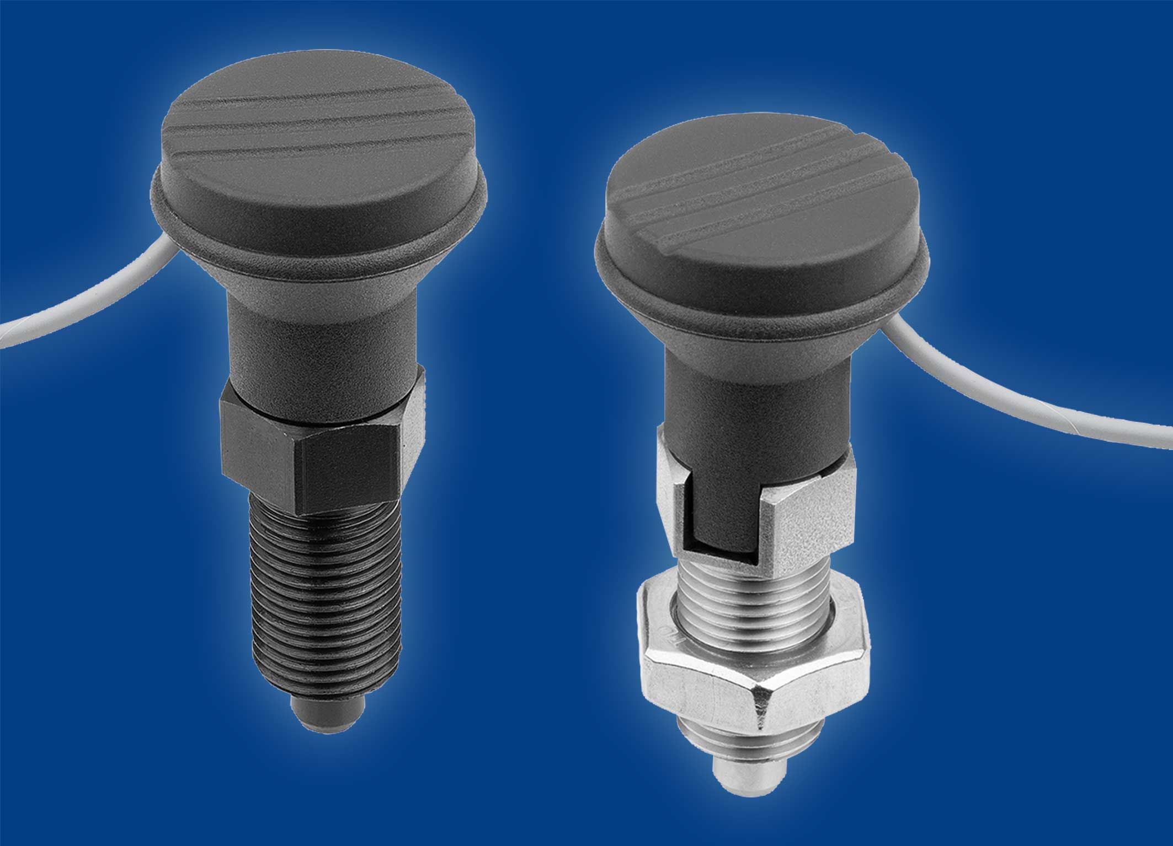
HEINRICH KIPP WERK now has a new wired indexing plunger with status sensor in its product range.
Image: KIPP

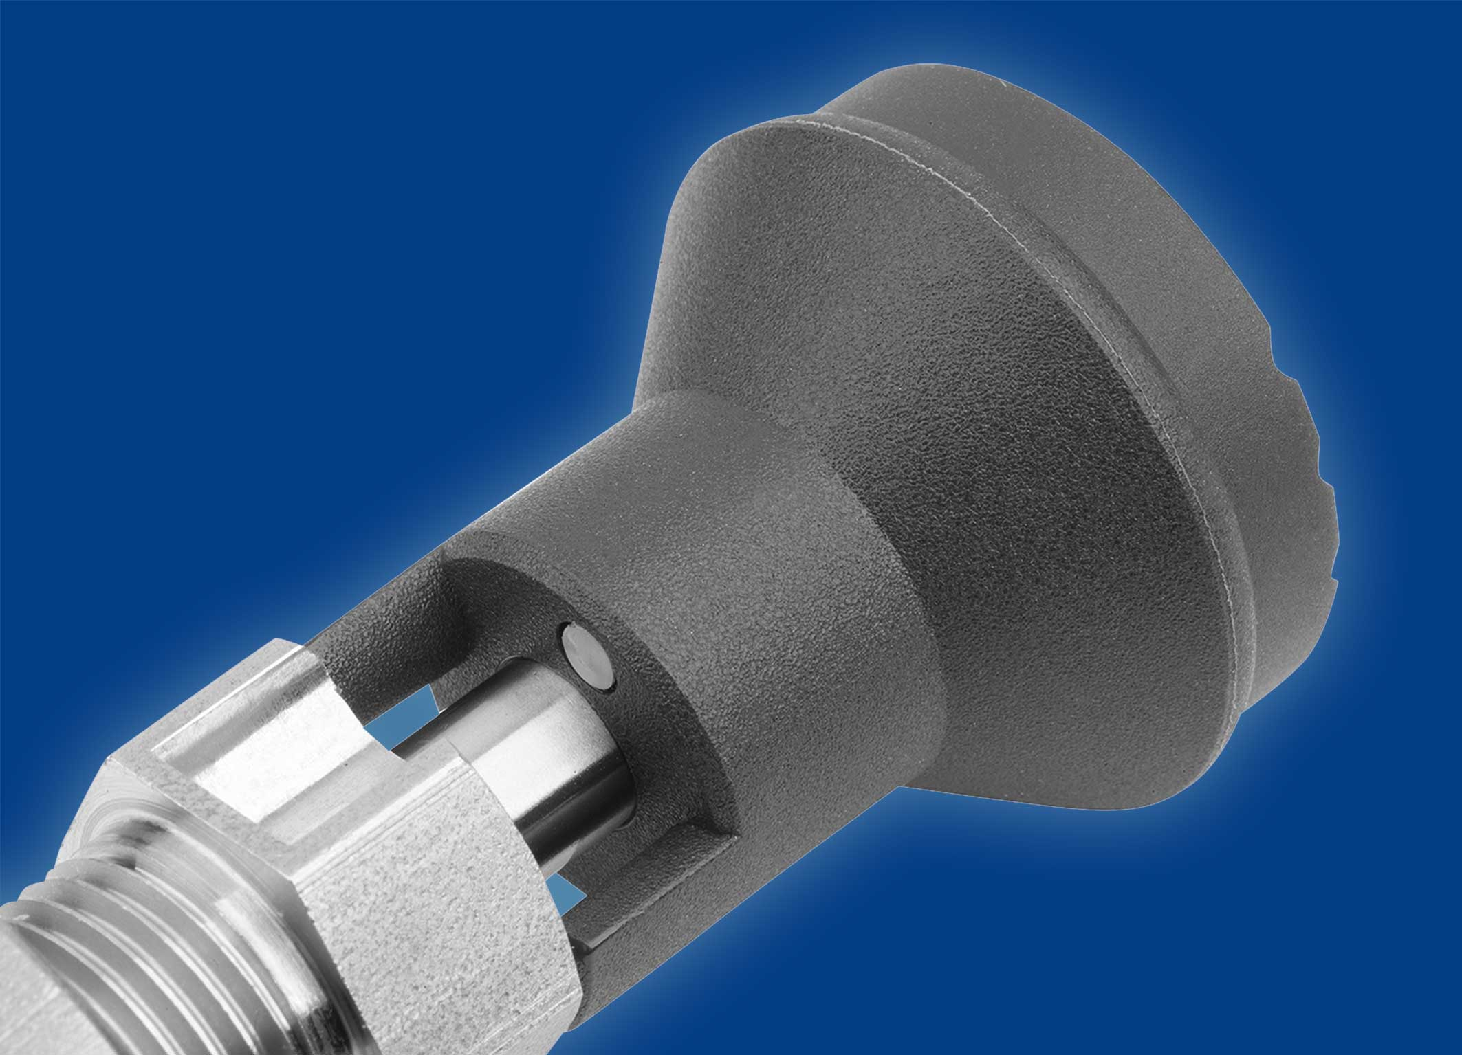
The sensor is integrated into the grip and activates as soon as the pin is retracted 1 mm.
Image: KIPP

HEINRICH KIPP WERK GmbH & Co. KG
Stefanie Beck, Marketing
Heubergstrasse 2
72172 Sulz am Neckar, Germany

Telephone: +49 7454 793-30
Email: stefanie.beck@kipp.com

