Sulz am Neckar, October 2021

KIPP presents a new fastener system in Hygienic DESIGN

HEINRICH KIPP WERK has developed a new fastening system for application areas in which hygiene plays an important role. The cavity-free solution in which all components are optimally matched to each other, has been designed for easy cleaning and is an alternative to the Hygienic USIT® fastening system.

The fastening system is characterised by flowing radii and transitions; it is free of grooves, burrs or uneven head seating. Inner radii of > 3 mm and a mean surface finish of < 0.8 µm ensure easy cleaning - so germs don't stand a chance. To facilitate frequent cleaning, the product is resistant to cleaning media with a pH value between pH4 and pH14 as well as strong alkalis (e.g. 50 % NaOH). EU10/2011 and FDA CFR21 directives are fulfilled.

This complete concept is an in-house development from KIPP. The uniform design of the screws and cap nuts ensures not only high functionality but also visual coherence. The domed-head forms are a protected design. The sealing ring made of the thermoplastic material POM is pre-mounted on the screw or nut, but can be exchanged and ordered separately. It is coloured ultramarine blue (RAL5002) - the industry-standard colour for identifying foreign bodies in foodstuffs. Due to the cleaning-optimised geometry, good hydrolysis resistance and the extended temperature range of -20 to +100 °C, it meets Hygienic DESIGN requirements. Screw and nut are made of stainless steel 1.4404 and are available in sizes M4 - M16. Customers can choose between an unpolished or polished version.

(Characters including spaces: 1,582)

Image overview:
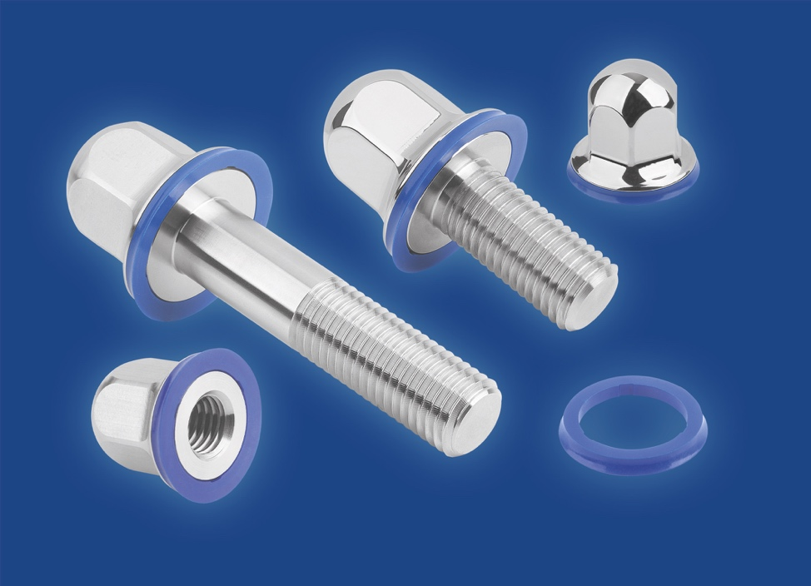
HEINRICH KIPP WERK has developed a new fastener system in Hygienic DESIGN.

HEINRICH KIPP WERK GmbH & Co. KG
Stefanie Beck, Marketing
Heubergstrasse 2
72172 Sulz am Neckar

Telephone: +49 7454 793-30
Email: stefanie.beck@kipp.com

