Press release Sulz am Neckar, Germany, November 2016

Mechanics with a click signal

KIPP introduces a new torque triangular grip

The HEINRICH KIPP WERK has expanded its range with a practical torque triangular grip. It signals when the maximum torque has been reached with an audible click.

The internal mechanics of the torque triangular grip developed by KIPP limit the tightening torque to 5 Nm. The grip can only be tightened up to the maximum torque. As soon as this is reached, a clear click tone can be heard. The grip prevents defined limits being accidentally exceeded. The grip can be used in all applications where a defined clamping force is demanded.

The KIPP torque triangular grip fulfils the highest quality standards and and fits seamlessly into the proven NOVO Grip product range. The grip is made from glass bead reinforced thermoplastic and the standard version is supplied in the colour black grey (RAL 7021).

The cap is made from the same coloured thermoplastic and the metal parts are made of hardened and electro-polished stainless steel. M8, M10 and M12 internal threads are available. Other sizes and other torques and colours are available on request.

Characters including spaces:
Headline: 47 Zeichen
Pre-head: 24 Zeichen
Text: 1.136 Zeichen
Total: 1.207 Zeichen

HEINRICH KIPP WERK KG
Stefanie Beck, Marketing
Heubergstraße 2
72172 Sulz am Neckar

Telephone: +49 (0) 7454 793-30
e-mail: stefanie.beck@kipp.com

Additional information and press photos
See www.kipp.com, Region: Germany, Category: News/Newsroom

Foto
KIPPTriangular torque grips K1019.jpg

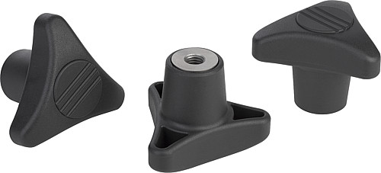

Image copyright: Released for licence-free and royalty-free publication in speciality media.
Please cite the source and submit a reference.

